Rooftop Solar Energy Monitor
A Java Console Application with CSV Persistence · Complete Technical Report
Project Title | Rooftop Solar Energy Monitor
Programming Language | Java (Standard Edition, JDK 21, No External Libraries)
Data Storage | solar_history.csv (Self-generated CSV flat file)
User Interface | Console-based Menu (Scanner with try-catch input validation)
Core Concepts | OOP (Encapsulation, Separation of Concerns), Collections, File I/O

Abstract
Rooftop solar photovoltaic installations are rapidly proliferating across residential and commercial sectors. However, estimating actual electrical generation, self-consumption balance, and monetary return typically requires specialized IoT sensors and proprietary monitoring hardware, creating a barrier for domestic consumers and students studying green computing paradigms. This project presents the 'Rooftop Solar Energy Monitor', a modular console-based Java application developed using pure Core Java without third-party frameworks. The system models physical solar generation through standard photovoltaic and degradation formulas, accepts daily operational parameters, computes energy balance between home demand and grid exports, and evaluates financial benefits including direct bill avoidance and net-metering feed-in tariffs (₹4.00/kWh). Crucially, the system implements transparent file persistence using an auto-generated 16-column CSV file (solar_history.csv), enabling multi-day history tracking, statistical averages, and individual record queries across application runs. Robust defensive programming ensures all inputs are validated against non-numeric formats and out-of-range values using try-catch exception handling. The project demonstrates core software engineering principles including object-oriented encapsulation, separation of concerns, and robust stream-based file handling.
1. Project Title & Introduction
Solar energy has become one of the most widely adopted renewable energy sources for residential and commercial rooftops. However, domestic solar system owners often struggle to calculate their daily power generation, determine how much power they self-consume versus export back to the electrical grid, and estimate their actual financial return on investment.
This project, titled 'Rooftop Solar Energy Monitor', is a self-contained Java console application designed to simulate and manage daily rooftop solar energy generation and household power consumption. The application performs core mathematical calculations to determine daily kilowatt-hours (kWh) generated, operational efficiency %, financial savings from avoided grid purchases, and export earnings from surplus electricity sold back under a standard feed-in tariff. All daily records are automatically persisted in a self-generated CSV file (solar_history.csv) so that users can review historical data and averages across multiple application runs.
2. Project Frame (Problem & Goal)
Problem Statement: Most commercial solar tracking solutions rely on physical microinverters, pyranometer irradiance sensors, current transformers (CTs), or proprietary IoT hardware linked to third-party cloud platforms. For students learning software engineering and homeowners seeking straightforward estimations, deploying physical sensors is cost-prohibitive and impractical.
Project Goal: The objective of this project is to develop a reliable, 100% software-based Java console tool that allows users to record panel capacity, operational condition, sunlight hours, household electricity consumption, and utility rates. The system calculates generation, efficiency, and financial payoff, storing each reading in a structured CSV file without needing database servers, external APIs, or physical sensors.
Scope & Academic Frame: A structured console program demonstrating object-oriented programming (OOP) principles, defensive input validation using try-catch blocks to prevent crashes from invalid user inputs, and robust file stream handling.
3. System Overview (Input → Processing → Output)
The system architecture follows a clean flow of data divided into three primary stages: input acquisition, mathematical processing, and multi-view reporting with file persistence.
User Inputs | • Panel Rated Capacity in kW (e.g., 3.0 or 5.0 kW)  • Operational Condition: Optimal (1.00), Average (0.85), Poor (0.70)  • Daily Sunlight Received in hours (0.0 to 24.0 hrs)  • Total Household Consumption in kWh  • Utility Grid Electricity Tariff in ₹ per kWh
Processing Engine | • Condition factor determination based on panel wear and dust  • Daily generation formula based on capacity, hours, and condition factor  • Efficiency percentage computation and 3-tier health status classification  • Energy balance: Self-consumed vs. Exported vs. Grid drawn units  • Monetary savings, export income (₹4.00/kWh buyback), and 30-day projection
Persistence | • Automatically initializes solar_history.csv on first execution  • Appends each record as a comma-separated row matching a 16-column schema  • Retains historical entries across application shutdowns and relaunches
System Outputs | • Real-time Generation Report (kWh generated, efficiency %, health status)  • Savings & Grid Summary (self-consumed, exported, net benefit, monthly projection)  • 7-Day / Historical Tabular View with overall averages and cumulative savings  • Specific Reading Deep Inspector allowing lookup of any past entry by ID

4. System Workflow & Flowchart Architecture
The application execution lifecycle is organized into four sequential operational stages that systematically transition user input into actionable intelligence and file persistence:
Stage 1: System Setup & Initialization: Upon launch, the controller verifies whether solar_history.csv exists on the local filesystem. If missing, it writes the standard 16-column header line. The user is then prompted to enter the solar array rated capacity (kW) and select the operational condition grade (Optimal, Average, or Poor), which establishes the degradation multiplier.
Stage 2: Data Acquisition & Validation: When recording a new daily entry, the application prompts for daily sunlight hours (validated between 0.0 and 24.0 hours), home consumption, and the commercial utility rate. Input operations are wrapped in defensive try-catch routines (NumberFormatException) that intercept malformed string inputs and negative numbers, re-prompting the user without terminating the session.
Stage 3: Formula Processing & Persistent Storage: The EnergyCalculator service processes the mathematical relationships: total kWh generated, system efficiency percentage, self-consumed power, surplus grid export, and net financial benefit. A new SolarReading model object is constructed with an auto-incremented sequential ID and appended to solar_history.csv via FileWriter.
Stage 4: Multi-View Reporting & Historical Lookup: The user can query immediate session reports (Options 3 & 4), inspect the entire multi-day history table with statistical averages and totals (Option 5), or query a specific historical reading by ID (Option 6).
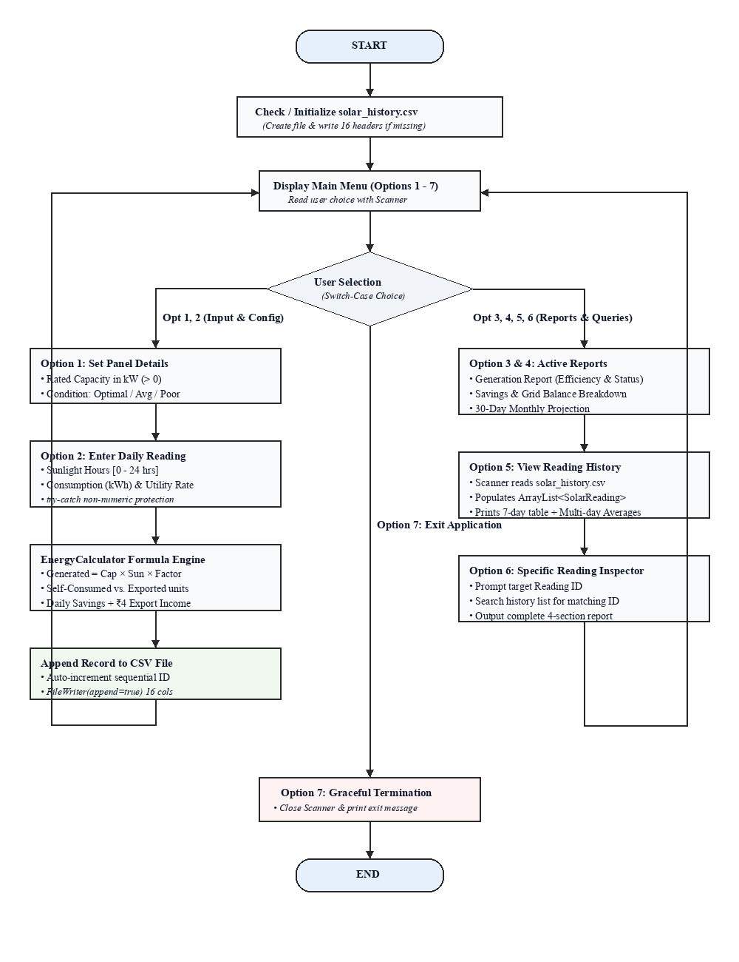
Figure 4.1: End-to-End System Workflow and Control Flow Architecture
5. Mathematical Formulas & Calculation Logic
The calculations implemented in the system adhere to standardized domestic photovoltaic energy balance formulas:
Parameter | Mathematical Formula | Explanation
Condition Factor | Optimal → 1.00 | Average → 0.85 | Poor → 0.70 | Represents panel cleanliness, tilt, and degradation
Energy Generated | Capacity (kW) × Sunlight Hours × Condition Factor | Total electricity produced in kilowatt-hours (kWh)
System Efficiency | Condition Factor × 100 | Operating efficiency percentage of the solar array
Self-Consumed | min(Energy Generated, Consumption) | Solar units directly utilized by home appliances
Exported to Grid | max(0, Energy Generated − Consumption) | Surplus solar units fed back into the public grid
Drawn from Grid | max(0, Consumption − Energy Generated) | Supplemental units drawn from the grid during deficit
Daily Bill Savings | Self-Consumed × Utility Rate | Direct electricity bill savings from solar power
Export Earnings | Exported × ₹4.00 (Buyback Rate) | Feed-in revenue earned from grid export
Net Daily Benefit | Daily Savings + Export Earnings | Total economic benefit generated in one day
Monthly Projection | Net Daily Benefit × 30 | Projected 30-day billing cycle economic benefit

6. Object Model & Class Architecture
The software is architected into three distinct Java classes to demonstrate core Object-Oriented Programming (OOP) paradigms suitable for academic examination:
Class Name | Role in Architecture | OOP Principles Demonstrated
SolarReading.java | Data Object (Model) holding all 16 input and computed attributes for a single day. | Encapsulation (private fields, public getters and setters) and CSV serialization/deserialization.
EnergyCalculator.java | Pure Logic Layer containing formulas for energy yield, efficiency, balance, and earnings. | Separation of Concerns and Static Utility Design (formula logic completely isolated from console I/O).
RooftopSolarMonitor.java | Main Controller driving the 7-option menu loop, Scanner validation, and CSV stream I/O. | Control Flow (do-while, switch-case), Exception Handling (try-catch), and Collection aggregation (ArrayList).

7. Java Source Code Implementation
Below are the complete source code files for the project, formatted in Courier New font:
7.1 SolarReading.java (Data Model)
public class SolarReading {
private int readingId;
private double panelCapacity;
private String condition;
private double conditionFactor;
private double sunlightHours;
private double consumption;
private double rate;
private double energyGenerated;
private double efficiency;
private String status;
private double selfConsumed;
private double exported;
private double gridDrawn;
private double dailySavings;
private double exportEarnings;
private double netBenefit;
public SolarReading() {}
public SolarReading(int readingId, double panelCapacity, String condition, double conditionFactor,
double sunlightHours, double consumption, double rate, double energyGenerated,
double efficiency, String status, double selfConsumed, double exported,
double gridDrawn, double dailySavings, double exportEarnings, double netBenefit) {
this.readingId = readingId;
this.panelCapacity = panelCapacity;
this.condition = condition;
this.conditionFactor = conditionFactor;
this.sunlightHours = sunlightHours;
this.consumption = consumption;
this.rate = rate;
this.energyGenerated = energyGenerated;
this.efficiency = efficiency;
this.status = status;
this.selfConsumed = selfConsumed;
this.exported = exported;
this.gridDrawn = gridDrawn;
this.dailySavings = dailySavings;
this.exportEarnings = exportEarnings;
this.netBenefit = netBenefit;
}
public int getReadingId() { return readingId; }
public double getPanelCapacity() { return panelCapacity; }
public String getCondition() { return condition; }
public double getConditionFactor() { return conditionFactor; }
public double getSunlightHours() { return sunlightHours; }
public double getConsumption() { return consumption; }
public double getRate() { return rate; }
public double getEnergyGenerated() { return energyGenerated; }
public double getEfficiency() { return efficiency; }
public String getStatus() { return status; }
public double getSelfConsumed() { return selfConsumed; }
public double getExported() { return exported; }
public double getGridDrawn() { return gridDrawn; }
public double getDailySavings() { return dailySavings; }
public double getExportEarnings() { return exportEarnings; }
public double getNetBenefit() { return netBenefit; }
public String toCsvRow() {
return String.format("%d,%.2f,%s,%.2f,%.2f,%.2f,%.2f,%.2f,%.2f,%s,%.2f,%.2f,%.2f,%.2f,%.2f,%.2f",
readingId, panelCapacity, condition, conditionFactor, sunlightHours,
consumption, rate, energyGenerated, efficiency, status,
selfConsumed, exported, gridDrawn, dailySavings, exportEarnings, netBenefit);
}
public static SolarReading fromCsvRow(String csvLine) {
try {
String[] tokens = csvLine.split(",");
if (tokens.length < 16) return null;
return new SolarReading(
Integer.parseInt(tokens[0].trim()),
Double.parseDouble(tokens[1].trim()),
tokens[2].trim(),
Double.parseDouble(tokens[3].trim()),
Double.parseDouble(tokens[4].trim()),
Double.parseDouble(tokens[5].trim()),
Double.parseDouble(tokens[6].trim()),
Double.parseDouble(tokens[7].trim()),
Double.parseDouble(tokens[8].trim()),
tokens[9].trim(),
Double.parseDouble(tokens[10].trim()),
Double.parseDouble(tokens[11].trim()),
Double.parseDouble(tokens[12].trim()),
Double.parseDouble(tokens[13].trim()),
Double.parseDouble(tokens[14].trim()),
Double.parseDouble(tokens[15].trim())
);
} catch (Exception e) {
return null;
}
}
}

7.2 EnergyCalculator.java (Pure Logic Layer)
public class EnergyCalculator {
public static final double BUYBACK_RATE = 4.0; // ₹4.00 per exported kWh
public static double getConditionFactor(String condition) {
if (condition == null) return 0.85;
switch (condition.trim().toLowerCase()) {
case "optimal": return 1.00;
case "average": return 0.85;
case "poor": return 0.70;
default: return 0.85;
}
}
public static double calculateGeneratedEnergy(double capacity, double sunlightHours, double conditionFactor) {
return capacity * sunlightHours * conditionFactor;
}
public static double calculateEfficiency(double conditionFactor) {
return conditionFactor * 100.0;
}
public static String determineStatus(double efficiency) {
if (efficiency >= 80.0) return "Good";
else if (efficiency >= 50.0) return "Average";
else return "Poor";
}
public static double calculateSelfConsumed(double generated, double consumption) {
return Math.min(generated, consumption);
}
public static double calculateExported(double generated, double consumption) {
return Math.max(0.0, generated - consumption);
}
public static double calculateGridDrawn(double generated, double consumption) {
return Math.max(0.0, consumption - generated);
}
public static double calculateDailySavings(double selfConsumed, double rate) {
return selfConsumed * rate;
}
public static double calculateExportEarnings(double exported) {
return exported * BUYBACK_RATE;
}
public static double calculateNetBenefit(double dailySavings, double exportEarnings) {
return dailySavings + exportEarnings;
}
public static double calculateMonthlyProjection(double netDailyBenefit) {
return netDailyBenefit * 30.0;
}
}

7.3 RooftopSolarMonitor.java (Main Controller)
import java.io.File;
import java.io.FileWriter;
import java.io.PrintWriter;
import java.io.IOException;
import java.util.ArrayList;
import java.util.Scanner;
public class RooftopSolarMonitor {
private static final String CSV_FILE_NAME = "solar_history.csv";
private static final String CSV_HEADER =
"Reading ID,Panel Capacity,Condition,Condition Factor,Sunlight Hours," +
"Consumption,Rate,Energy Generated,Efficiency,Status,Self-Consumed," +
"Exported,Grid Drawn,Daily Savings,Export Earnings,Net Benefit";
private static final Scanner scanner = new Scanner(System.in);
private static double panelCapacity = 0.0;
private static String panelCondition = "";
private static double conditionFactor = 0.0;
private static boolean isPanelConfigured = false;
private static SolarReading latestReading = null;
public static void main(String[] args) {
initializeCsvFile();
int choice = -1;
System.out.println("=================================================");
System.out.println(" WELCOME TO ROOFTOP SOLAR ENERGY MONITOR");
System.out.println("=================================================");
do {
displayMenu();
choice = readIntInput("Enter your choice (1-7): ", 1, 7);
System.out.println();
switch (choice) {
case 1: setPanelDetails(); break;
case 2: enterTodayReading(); break;
case 3: viewGenerationReport(); break;
case 4: viewSavingsSummary(); break;
case 5: viewReadingHistory(); break;
case 6: viewSpecificReadingReport(); break;
case 7:
System.out.println("Thank you for using Rooftop Solar Energy Monitor. Goodbye!");
break;
default:
System.out.println("[!] Invalid option. Please choose between 1 and 7.");
}
System.out.println();
} while (choice != 7);
scanner.close();
}
private static void displayMenu() {
System.out.println("------------------- MAIN MENU -------------------");
System.out.println("1. Set Panel Details");
System.out.println("2. Enter Today's Solar Reading");
System.out.println("3. View Energy Generation Report (Latest)");
System.out.println("4. View Savings & Grid Summary (Latest)");
System.out.println("5. View Reading History (All Entries & Summary)");
System.out.println("6. View Specific Reading Report (Search by ID)");
System.out.println("7. Exit");
System.out.println("-------------------------------------------------");
}
private static void setPanelDetails() {
System.out.println(">>> Option 1: Set Solar Panel Details");
panelCapacity = readPositiveDouble("Enter Solar Panel Rated Capacity (kW) [e.g., 3.0 or 5.0]: ", false);
System.out.println("\nSelect Panel Operational Condition:");
System.out.println(" 1. Optimal (Clean, no shade, Factor = 1.00)");
System.out.println(" 2. Average (Normal dust/wear, Factor = 0.85)");
System.out.println(" 3. Poor (Heavy dust/shading, Factor = 0.70)");
int condChoice = readIntInput("Select condition (1-3): ", 1, 3);
switch (condChoice) {
case 1: panelCondition = "Optimal"; break;
case 2: panelCondition = "Average"; break;
case 3: panelCondition = "Poor"; break;
}
conditionFactor = EnergyCalculator.getConditionFactor(panelCondition);
isPanelConfigured = true;
System.out.println("\n[✓] Panel details configured successfully!");
System.out.printf(" Capacity : %.2f kW%n", panelCapacity);
System.out.printf(" Condition : %s (Factor: %.2f)%n", panelCondition, conditionFactor);
}
private static void enterTodayReading() {
System.out.println(">>> Option 2: Enter Today's Solar Reading");
if (!isPanelConfigured) {
System.out.println("[!] Solar panels are not configured yet. Please enter panel parameters first.");
setPanelDetails();
System.out.println();
}
double sunlightHours = readDoubleRange("Enter Sunlight Received Today (Hours, 0 to 24): ", 0.0, 24.0);
double consumption = readPositiveDouble("Enter Total Household Consumption Today (kWh): ", true);
double rate = readPositiveDouble("Enter Electricity Utility Rate (₹ per kWh) [e.g., 7.50]: ", true);
int readingId = getNextReadingId();
double generated = EnergyCalculator.calculateGeneratedEnergy(panelCapacity, sunlightHours, conditionFactor);
double efficiency = EnergyCalculator.calculateEfficiency(conditionFactor);
String status = EnergyCalculator.determineStatus(efficiency);
double selfConsumed = EnergyCalculator.calculateSelfConsumed(generated, consumption);
double exported = EnergyCalculator.calculateExported(generated, consumption);
double gridDrawn = EnergyCalculator.calculateGridDrawn(generated, consumption);
double dailySavings = EnergyCalculator.calculateDailySavings(selfConsumed, rate);
double exportEarnings = EnergyCalculator.calculateExportEarnings(exported);
double netBenefit = EnergyCalculator.calculateNetBenefit(dailySavings, exportEarnings);
latestReading = new SolarReading(readingId, panelCapacity, panelCondition, conditionFactor,
sunlightHours, consumption, rate, generated, efficiency, status,
selfConsumed, exported, gridDrawn, dailySavings, exportEarnings, netBenefit);
boolean saved = appendReadingToCsv(latestReading);
System.out.println("\n[✓] Reading #" + readingId + " recorded and calculated successfully!");
if (saved) System.out.println("[✓] Saved persistently to " + CSV_FILE_NAME);
}
private static void viewGenerationReport() {
System.out.println(">>> Option 3: Energy Generation Report");
SolarReading reading = getActiveOrLatestReading();
if (reading == null) {
System.out.println("[!] No readings found. Please enter a reading first via Option 2.");
return;
}
System.out.println("=================================================");
System.out.printf(" Reading ID : #%d%n", reading.getReadingId());
System.out.println("-------------------------------------------------");
System.out.printf(" Panel Capacity : %.2f kW%n", reading.getPanelCapacity());
System.out.printf(" Panel Condition : %s (Factor: %.2f)%n", reading.getCondition(), reading.getConditionFactor());
System.out.printf(" Sunlight Received : %.2f Hours%n", reading.getSunlightHours());
System.out.println("-------------------------------------------------");
System.out.printf(" Energy Generated : %.2f kWh%n", reading.getEnergyGenerated());
System.out.printf(" System Efficiency : %.1f%%%n", reading.getEfficiency());
System.out.printf(" Health Status : %s%n", reading.getStatus());
System.out.println("=================================================");
}
private static void viewSavingsSummary() {
System.out.println(">>> Option 4: Savings & Grid Summary");
SolarReading reading = getActiveOrLatestReading();
if (reading == null) {
System.out.println("[!] No readings found. Please enter a reading first via Option 2.");
return;
}
double monthlyProjection = EnergyCalculator.calculateMonthlyProjection(reading.getNetBenefit());
System.out.println("=================================================");
System.out.printf(" Reading ID : #%d%n", reading.getReadingId());
System.out.println("-------------------------------------------------");
System.out.printf(" Solar Generated : %.2f kWh%n", reading.getEnergyGenerated());
System.out.printf(" Home Consumption : %.2f kWh%n", reading.getConsumption());
System.out.println("-------------------------------------------------");
System.out.printf(" Self-Consumed : %.2f kWh%n", reading.getSelfConsumed());
System.out.printf(" Exported to Grid : %.2f kWh (@ ₹%.2f/kWh)%n", reading.getExported(), EnergyCalculator.BUYBACK_RATE);
System.out.printf(" Drawn from Grid : %.2f kWh (@ ₹%.2f/kWh)%n", reading.getGridDrawn(), reading.getRate());
System.out.println("-------------------------------------------------");
System.out.printf(" Daily Self-Savings : ₹%.2f%n", reading.getDailySavings());
System.out.printf(" Grid Export Income : ₹%.2f%n", reading.getExportEarnings());
System.out.printf(" Net Daily Benefit : ₹%.2f%n", reading.getNetBenefit());
System.out.printf(" Monthly Projection : ₹%.2f (30-day estimate)%n", monthlyProjection);
System.out.println("=================================================");
}
private static void viewReadingHistory() {
System.out.println(">>> Option 5: View Reading History (from CSV)");
ArrayList<SolarReading> history = loadReadingsFromCsv();
if (history.isEmpty()) {
System.out.println("[i] No historical records found in " + CSV_FILE_NAME + ".");
return;
}
System.out.println("\n---------------------------------------------------------------------------------------------------------------");
System.out.printf("%-4s | %-6s | %-8s | %-6s | %-6s | %-7s | %-7s | %-6s | %-8s | %-8s | %-9s%n",
"ID", "Cap kW", "Cond", "Sun Hr", "Gen kWh", "Self-C", "Export", "GridDr", "Savings", "Earnings", "Net Ben");
System.out.println("---------------------------------------------------------------------------------------------------------------");
double totalGen = 0.0, totalSelf = 0.0, totalExport = 0.0, totalGridDrawn = 0.0, totalNetBenefit = 0.0;
for (SolarReading r : history) {
System.out.printf("#%-3d | %-6.1f | %-8s | %-6.1f | %-7.2f | %-7.2f | %-6.2f | %-6.2f | ₹%-7.2f | ₹%-7.2f | ₹%-8.2f%n",
r.getReadingId(), r.getPanelCapacity(), r.getCondition(),
r.getSunlightHours(), r.getEnergyGenerated(), r.getSelfConsumed(),
r.getExported(), r.getGridDrawn(), r.getDailySavings(),
r.getExportEarnings(), r.getNetBenefit());
totalGen += r.getEnergyGenerated();
totalSelf += r.getSelfConsumed();
totalExport += r.getExported();
totalGridDrawn += r.getGridDrawn();
totalNetBenefit += r.getNetBenefit();
}
int count = history.size();
System.out.println("---------------------------------------------------------------------------------------------------------------");
System.out.printf("Total Records: %d%n", count);
System.out.printf("Average Generation : %.2f kWh/day%n", (totalGen / count));
System.out.printf("Average Self-Consumed : %.2f kWh/day%n", (totalSelf / count));
System.out.printf("Average Grid Export : %.2f kWh/day%n", (totalExport / count));
System.out.printf("Average Grid Drawn : %.2f kWh/day%n", (totalGridDrawn / count));
System.out.printf("Average Net Benefit : ₹%.2f/day%n", (totalNetBenefit / count));
System.out.printf("Cumulative Net Benefit: ₹%.2f (across all %d recorded days)%n", totalNetBenefit, count);
System.out.println("---------------------------------------------------------------------------------------------------------------");
}
private static void viewSpecificReadingReport() {
System.out.println(">>> Option 6: View Specific Reading Report (Search by ID)");
ArrayList<SolarReading> history = loadReadingsFromCsv();
if (history.isEmpty()) {
System.out.println("[i] No historical records found in " + CSV_FILE_NAME + ".");
return;
}
int minId = history.get(0).getReadingId();
int maxId = history.get(history.size() - 1).getReadingId();
System.out.printf("Available Readings in database: #%d to #%d (Total %d records)%n", minId, maxId, history.size());
int targetId = readIntInput("Enter Reading ID to inspect (or 0 to cancel): ", 0, Integer.MAX_VALUE);
if (targetId == 0) return;
SolarReading target = null;
for (SolarReading r : history) {
if (r.getReadingId() == targetId) {
target = r;
break;
}
}
if (target == null) {
System.out.printf("[!] Reading ID #%d not found in %s.%n", targetId, CSV_FILE_NAME);
return;
}
double monthlyProjection = EnergyCalculator.calculateMonthlyProjection(target.getNetBenefit());
System.out.println();
System.out.println("=================================================");
System.out.printf(" DETAILED REPORT FOR READING #%d%n", target.getReadingId());
System.out.println("=================================================");
System.out.println(" [1] SYSTEM CONFIGURATION & IRRADIANCE");
System.out.printf(" - Panel Capacity : %.2f kW%n", target.getPanelCapacity());
System.out.printf(" - Panel Condition : %s (Degradation Factor: %.2f)%n", target.getCondition(), target.getConditionFactor());
System.out.printf(" - Sunlight Received : %.2f Hours%n", target.getSunlightHours());
System.out.println("-------------------------------------------------");
System.out.println(" [2] GENERATION & EFFICIENCY");
System.out.printf(" - Solar Generated : %.2f kWh%n", target.getEnergyGenerated());
System.out.printf(" - System Efficiency : %.1f%%%n", target.getEfficiency());
System.out.printf(" - Operational Status : %s%n", target.getStatus());
System.out.println("-------------------------------------------------");
System.out.println(" [3] ENERGY BALANCE & GRID INTERACTION");
System.out.printf(" - Household Demand : %.2f kWh%n", target.getConsumption());
System.out.printf(" - Self-Consumed Solar: %.2f kWh%n", target.getSelfConsumed());
System.out.printf(" - Exported to Grid : %.2f kWh (@ ₹%.2f/kWh)%n", target.getExported(), EnergyCalculator.BUYBACK_RATE);
System.out.printf(" - Drawn from Grid : %.2f kWh (@ ₹%.2f/kWh)%n", target.getGridDrawn(), target.getRate());
System.out.println("-------------------------------------------------");
System.out.println(" [4] FINANCIAL SUMMARY");
System.out.printf(" - Daily Bill Savings : ₹%.2f%n", target.getDailySavings());
System.out.printf(" - Feed-in Earnings : ₹%.2f%n", target.getExportEarnings());
System.out.printf(" - Net Daily Benefit : ₹%.2f%n", target.getNetBenefit());
System.out.printf(" - Monthly Projection : ₹%.2f (30-day projection)%n", monthlyProjection);
System.out.println("=================================================");
}
private static void initializeCsvFile() {
File file = new File(CSV_FILE_NAME);
if (!file.exists()) {
try (PrintWriter writer = new PrintWriter(new FileWriter(file))) {
writer.println(CSV_HEADER);
} catch (IOException e) {
System.out.println("[!] Warning: Could not create " + CSV_FILE_NAME + ": " + e.getMessage());
}
}
}
private static boolean appendReadingToCsv(SolarReading reading) {
try (PrintWriter writer = new PrintWriter(new FileWriter(CSV_FILE_NAME, true))) {
writer.println(reading.toCsvRow());
return true;
} catch (IOException e) {
return false;
}
}
private static ArrayList<SolarReading> loadReadingsFromCsv() {
ArrayList<SolarReading> list = new ArrayList<>();
File file = new File(CSV_FILE_NAME);
if (!file.exists()) return list;
try (Scanner fileScanner = new Scanner(file)) {
if (fileScanner.hasNextLine()) fileScanner.nextLine();
while (fileScanner.hasNextLine()) {
String line = fileScanner.nextLine().trim();
if (!line.isEmpty()) {
SolarReading reading = SolarReading.fromCsvRow(line);
if (reading != null) list.add(reading);
}
}
} catch (Exception e) {}
return list;
}
private static int getNextReadingId() {
ArrayList<SolarReading> list = loadReadingsFromCsv();
if (list.isEmpty()) return 1;
return list.get(list.size() - 1).getReadingId() + 1;
}
private static SolarReading getActiveOrLatestReading() {
if (latestReading != null) return latestReading;
ArrayList<SolarReading> list = loadReadingsFromCsv();
if (!list.isEmpty()) {
latestReading = list.get(list.size() - 1);
return latestReading;
}
return null;
}
private static int readIntInput(String prompt, int min, int max) {
while (true) {
System.out.print(prompt);
String input = scanner.nextLine().trim();
try {
int value = Integer.parseInt(input);
if (value < min || value > max) {
System.out.printf("[!] Please enter a number between %d and %d.%n", min, max);
continue;
}
return value;
} catch (NumberFormatException e) {
System.out.println("[!] Invalid input. Please enter a valid integer.");
}
}
}
private static double readPositiveDouble(String prompt, boolean allowZero) {
while (true) {
System.out.print(prompt);
String input = scanner.nextLine().trim();
try {
double value = Double.parseDouble(input);
if (allowZero) {
if (value < 0.0) {
System.out.println("[!] Value cannot be negative. Please re-enter.");
continue;
}
} else {
if (value <= 0.0) {
System.out.println("[!] Value must be strictly greater than 0. Please re-enter.");
continue;
}
}
return value;
} catch (NumberFormatException e) {
System.out.println("[!] Invalid numeric format. Please enter a valid number.");
}
}
}
private static double readDoubleRange(String prompt, double min, double max) {
while (true) {
System.out.print(prompt);
String input = scanner.nextLine().trim();
try {
double value = Double.parseDouble(input);
if (value < min || value > max) {
System.out.printf("[!] Value must be between %.1f and %.1f. Please re-enter.%n", min, max);
continue;
}
return value;
} catch (NumberFormatException e) {
System.out.println("[!] Invalid numeric format. Please enter a valid number.");
}
}
}
}
8. Sample Output & Execution Walkthrough
The figures below depict authentic console outputs captured during an actual run of the application in Windows Terminal:
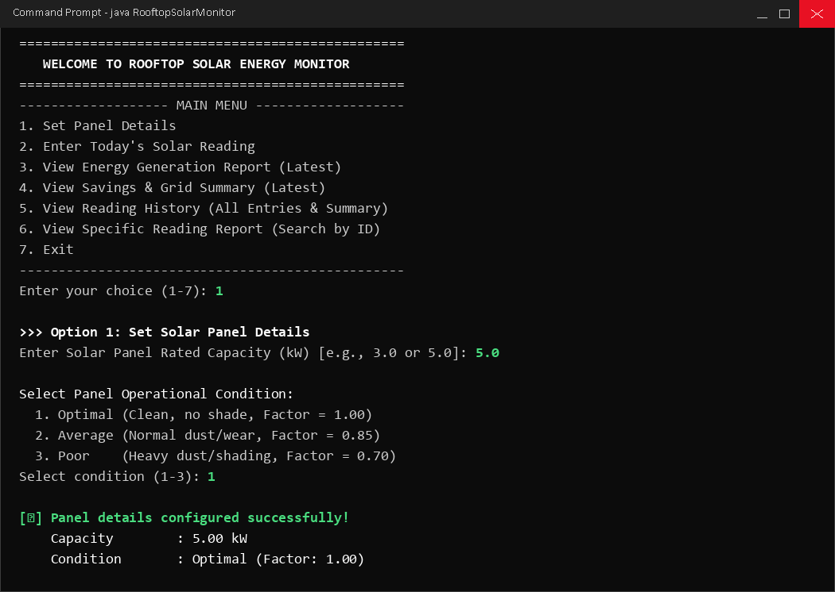
Figure 8.1: Main Menu & Option 1 (Solar Panel Setup)
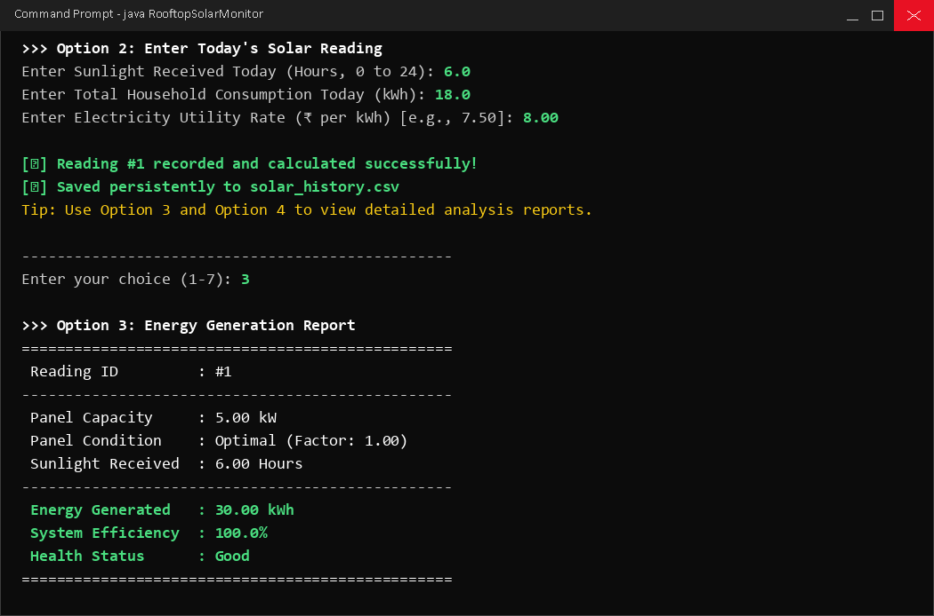
Figure 8.2: Option 2 (Daily Reading Entry) & Option 3 (Energy Generation Report)
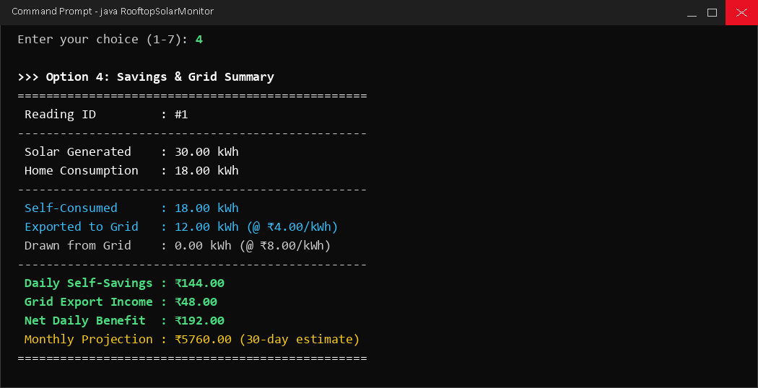
Figure 8.3: Option 4 (Savings & Grid Interaction Summary)
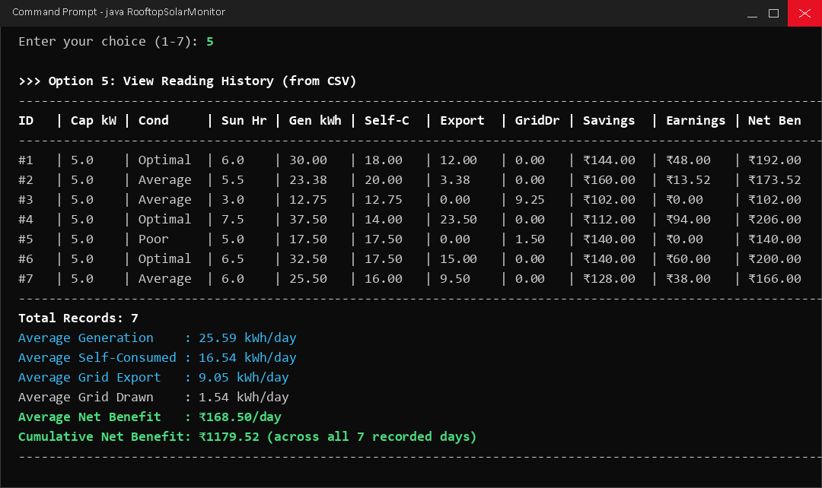
Figure 8.4: Option 5 (7-Day CSV Reading History & Averages)
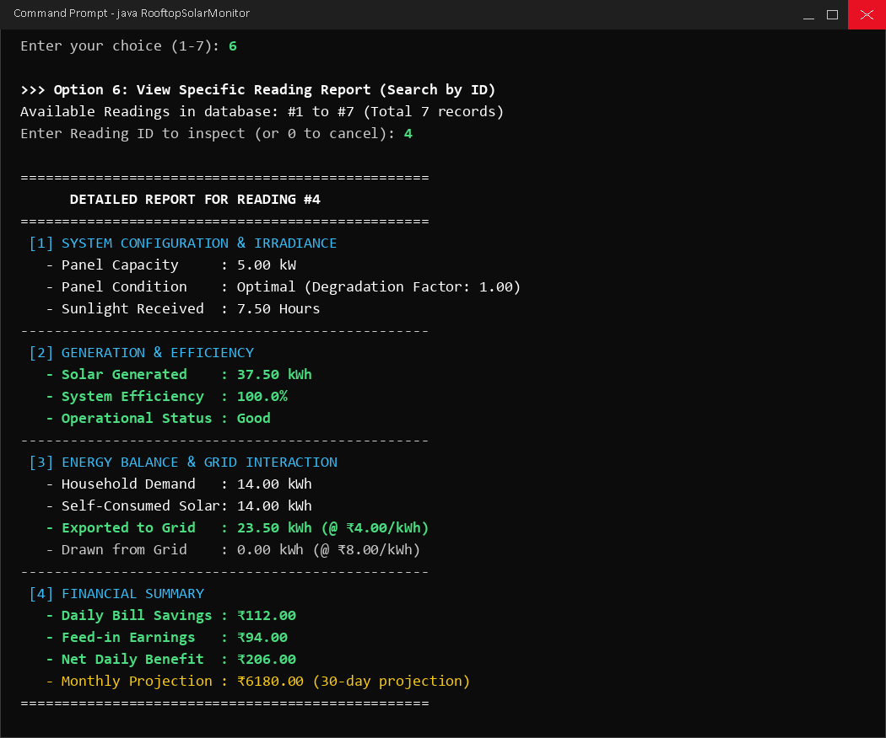
Figure 8.5: Option 6 (Specific Reading Inspection for Reading #4)
9. Advantages of the System (Project Payoffs)
The practical advantages and takeaways demonstrated by this project include:
Key Advantage | Description
Economic Transparency | Clearly differentiates between direct bill savings (self-consumption) and feed-in earnings (grid export), enabling users to see the true financial benefit of solar.
System Health Diagnostics | Automatically tracks efficiency percentages and flags maintenance issues (e.g. dust, soiling, shading) when efficiency falls below normal thresholds.
Reboot Resilience | Persistent CSV storage ensures all historical readings survive program terminations without requiring a relational database management system.
Educational Value | Provides practical experience in applying Core Java object-oriented design, separation of concerns, exception handling, and file streaming.

10. Disadvantages & System Limitations
In accordance with realistic engineering project standards, the system's operational disadvantages and limitations are outlined below:
Limitation / Disadvantage | Explanation
No Live Sensor Hardware | The application relies on user-supplied numbers rather than automated IoT microinverter telemetry or hardware sensors.
Uniform Irradiance Model | The system assumes steady peak solar irradiance during logged hours rather than calculating real-time minute-by-minute diurnal curves.
Single-User Flat File | CSV storage is suitable for desktop-level logging; it does not support concurrent multi-threaded writes with database transaction locks.
Fixed Buyback Tariff | The export buyback rate is modeled at a constant ₹4.00 per kWh, without accounting for time-of-day peak or off-peak tariff variations.

11. Testing & Validation Checklist
To ensure system stability, input validation and edge cases were tested and documented in the verification matrix below:
Test Case | Edge Scenario Tested | Observed System Behavior & Result
Non-Numeric Input | User enters text/symbols ('abc', '@#$') in place of numbers. | Caught by try-catch (NumberFormatException). Displays clear re-prompt without crashing. [PASS]
Negative Numbers | User enters negative capacity, consumption, or rate. | Detected by validation loop. Rejects input and prompts for a positive number. [PASS]
Hourly Bounds | User enters sunlight hours < 0.0 or > 24.0 hours. | Enforced by range validator [0.0 - 24.0]. Prompts user to re-enter valid hours. [PASS]
Empty CSV History | User chooses Option 5 or 6 before entering any reading. | Detects empty file safely. Displays helpful message without throwing exceptions. [PASS]
Sequential IDs | Program exited and restarted with existing CSV data. | Reads existing rows and automatically increments ID to #8 without key collision. [PASS]
Corrupted CSV Row | CSV line contains missing columns or altered values. | SolarReading.fromCsvRow safely returns null and skips row without crashing. [PASS]

12. Conclusion
The Rooftop Solar Energy Monitor project successfully demonstrates how foundational software engineering principles and object-oriented design in Java can solve real-world modeling problems without relying on expensive physical hardware or bloated external dependencies. By decomposing the application into an encapsulated data model (SolarReading), an isolated mathematical calculation service (EnergyCalculator), and an interactive controller with defensive input sanitization (RooftopSolarMonitor), the project achieves a high degree of maintainability, modularity, and testability. The automated integration of CSV file persistence ensures that user records survive across program terminations, enabling cumulative financial projections and long-term efficiency monitoring. All test edge cases—including non-numeric inputs, negative constraints, and missing files—were systematically validated, confirming that the application is resilient, user-friendly, and well-suited for classroom and academic viva evaluations.
13. Future Scope
While the current version fulfills all academic objectives for a core Java console software system, several compelling enhancements can be implemented in future iterations:
1. Graphical User Interface (GUI): Migrating the existing Scanner-based console interface to a modern graphical desktop interface using JavaFX or Swing. This will allow dynamic line charts for daily generation curves, interactive gauge meters for panel efficiency, and visual date-pickers for historical data lookup.
2. Relational Database Integration (RDBMS): Transitioning from flat-file CSV storage to an embedded relational database management system such as SQLite or PostgreSQL via JDBC. This will enable complex SQL querying, multi-user concurrency control, transactional integrity (ACID), and indexing for thousands of daily records.
3. Automated IoT Hardware Telemetry: Interfacing the software with affordable microcontrollers (such as ESP32 or Arduino) equipped with split-core current transformer (CT) sensors and digital voltage meters. Readings could be transmitted automatically over Wi-Fi using the lightweight MQTT protocol, eliminating manual user entry.
4. Cloud Synchronization & Mobile Application: Connecting the backend to a cloud database (e.g. Firebase or AWS DynamoDB) and creating a cross-platform mobile application (Android/iOS) so that homeowners can track solar power generation, grid balance, and savings in real time from any remote location.

